Project Design Phase-II Data Flow Diagram &User Stories

|  |  |
| --- | --- |
| Date | 19 October 2022 |
| Team ID | PNT2022TMID37769 |
| Project Name | Project-IOT based smart crop protection system for agriculture |
| Maximum Marks | 4 Marks |

# Data Flow Diagrams:

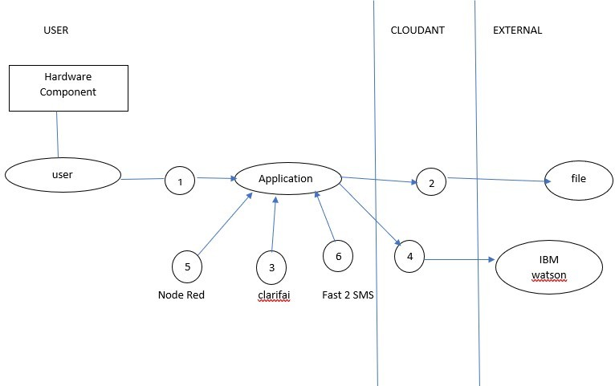A Data Flow Diagram (DFD) is a traditional visual representation of the information flows within a system. A neat and clear DFD can depict the right amount of the system requirement graphically. It shows how data enters and leaves the system, what changes the information, and where data is stored.

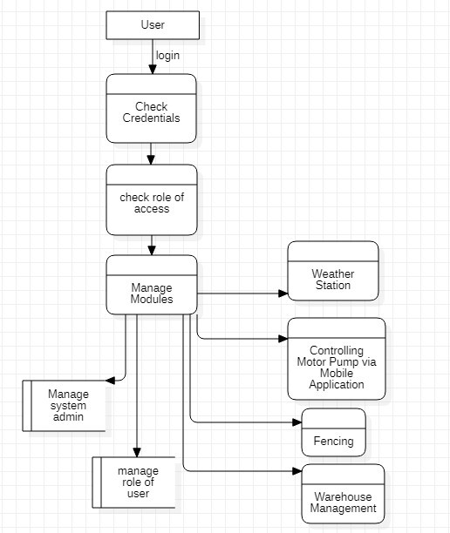

Example: DFD Level 0 (Industry Standard)

# User Stories

|  |  |  |  |  |  |  |
| --- | --- | --- | --- | --- | --- | --- |
| **User Type** | **Functional**  **Requirement (Epic)** | **User Story Number** | **User Story / Task** | **Acceptance criteria** | **Priority** | **Release** |
| Customer | Registration | USN-1 | As a user, I can register for the application by  entering my email, password, and confirming my password. | I can access my account / dashboard. | High | Sprint-1 |
| Customer | Registration | USN-2 | As a user, I will receive confirmation message  once I have registered for the application. | I can receive confirmation  message & click confirm. | High | Sprint-1 |
| Administrator | Login page | USN-3 | As a user entering the username and  password which is already existing. | Redirecting to user  account. | Medium | Sprint-1 |
| Weather station | Forecasting the current weather | USN-4 | As a user, we can monitor the weather  fundamentals like (humidity, wind speed, wind direction and rainfall). | Notified about weather conditions. | High | Sprint-1 |
| Controlling the Motor Pump | Controlling | USN-5 | It is used to control motors and field sprinklers. | Switching on and off the motor pump manually via  mobile application | High | Sprint-2 |
| Fencing | Detecting the motion in certain  range | USN-6 | Fencing system are helpful in providing security against unauthorized access of human  and animal. | I can receive notification; prevention has been taken. | High | Sprint-3 |
| Warehouse management | Collecting database of crops | USN-7 | Here famer need to update about expire date of fertilizer and seeds. | Generate the popup  message about expire date and stocks and offers | High | Sprint-4 |